1 Introduction.
1.1 Waveform coding.
In waveform coding, we try to find an efficient representation of the waveform, directly. In this methods we use the correlation between two or more step samples or a complex quantize algorithm.
1.2 Transform coding.
Two major types of frequency-domain speech coders are subband coders (SBC) and adaptive transform coders (ATC).
In SBCs, the speech is divided into four or more frequency bands and each of these subband signals is coded separately.In ATCs the speech is divided into blocks, each speech block is transformed, and the transform coefficients are coded. The primary difference is that transform coders usually have more channels and poorer equivalent channel subband coders.
1.3 Parametric coding.
In this speech coding, we try to find a small set of parameters that are an efficient representation of the signal, instead of coding the waveform itself. We look for some parameters that can describe it accurately. The main parametric method used today is LPC, which has mathematically tractable and well-understood model. This model is closely related to physical and phonetic parameters and it can be parameterized in various ways.
There are very many variants over the basic scheme: LPC-10, CELP, MELP, RELP, VSELP, ASELP, LD-CELP, ...
All those methods have a difference in bit-rate, complexity, delay, robustness and quality.
2. Sub band Coder.
Sub band processing is based on splitting the frequency range into M segments (subbands),which together encompass the entire range. Each subband is processed independently, as called for by the specific application. The subbands are recombined after processing, to form an output signal whose bandwidth occupies the entire frequency range.

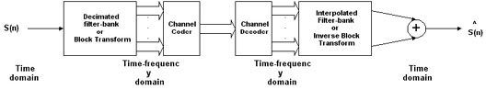
Basic Sub band Coder
2.1 Analysis.
In subband coding, the speech is first split into frequency bands using a bank of band-pass filters. The individual band pass signals are then decimated and encoded for transmission. A filter bank is a collection of band-pass filters, all processing the same input signal. The important parameters in subband coders are the number of frequency bands and the frequency coverage of the system, and the way subband coders are coded.
There are two kinds of subband structures: Uniform band structures, where all the bands have equal widths, and octave band structures, where the bandwidths are half as great as the higher adjacent band and twice as great as the lower adjacent band.
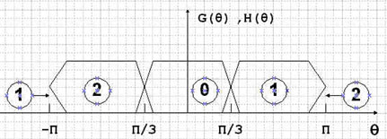
Uniform band

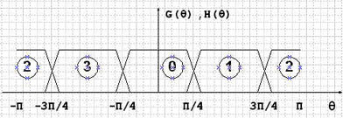 Octave band

2.1.1 Tree structured filter banks.
Splitting of a signal into 2^L channels is possible for any integer L using a tree structured filter bank. Each of the two outputs of the first level is passed to a two channel bank at a second level. This process can be continued according to the desired number of subbands.
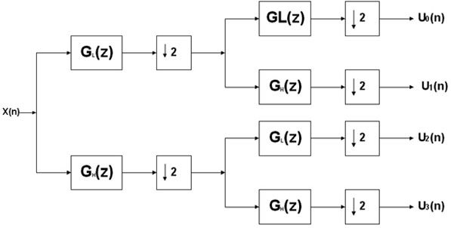
A tree structured analysis filter bank.
2.1.2 Filter Response
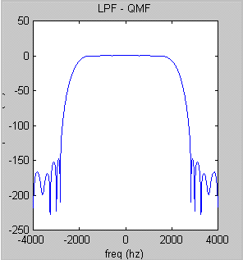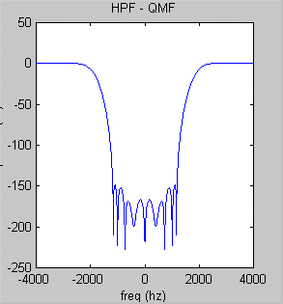
2.1.3 Decimation.
In the analysis stage we first divide the full bandwidth into two half-bands, the first band is 0-2000 Hz and the second is 2000-4000 Hz. This division gives us the ability to reduce the sample rate by half. This can be done by taking out every second sample.The bands are then split again, giving four bands of 0-1000 Hz, 1000-2000 Hz, 2000-3000 Hz and 3000-4000 Hz. Again we activate the decimation process to reduce the sample rate.This process can be repeated many times.
2.2 Process-The speech coding and decoding system.
2.2.1 Introduction
The task of the speech coder is to digitize the speech signal and represent it with a digital bit stream and to produce the highest possible speech quality at the lowest possible bit-rate. The speech coder generally consists of three components: speech analysis, parameter quantization and parameter coding. After analysis , the samples must be quantized to reduce the number of bits required. The output of the quantizer is provided to the coder which assigns a unique binary code to each possible quantized representation. These binary codes are packed together for efficient transmission.
Quantizers are generally divided in two: Uniform or nonuniform quantizers, and adaptive quantizers. A nonuniform quantizer or an adaptive quantizer followed by an encoder that assigns a code to each quantization level is called companding pulse code modulation (companding PCM) or adaptive pulse code modulation (APCM).
2.2.2 Synthesis & Recombination
The synthesis system perform the inverse of the analysis operation. Between every two samples in each band we put in the value zero to increase the sample rate.Then we merge the two lowest bands,for example: 0-1000 Hz and 1000-2000 Hz, into the reconstructed 0-2000 Hz band. The same operation is done to the other two bands, 2000-3000 Hz and 3000-4000 Hz , are merged into one band of 2000-4000 Hz. Again, we increase the sample rate in these two bands and merge them again.
A tree structured synthesis filter bank.
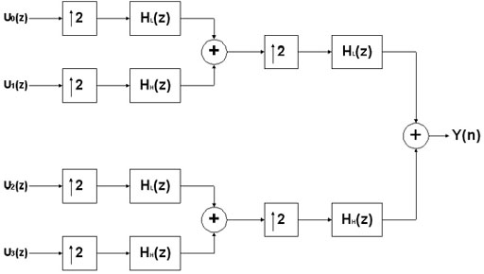
3. The development steps & wave files.
3.1 Analysis and Synthesis.
First, we carried out Subband coder by creating analysis and synthesis sections.This actions does not necessary add distortions in the voice,and the output is equal to the source, except for some loss of higher frequencies. We recorded our voice using sound recorder at 8KHz.It means the highest freq component is 4KHz which correspond to 1 in Matlab.It is computationally very intensive to take FFT of entire signal, therefore a better choice is to take some finite samples say 36000 for the purpose of computing FFT. We implemented the code by two methods
a).Without noble identities: In this method we passed the input signal(speech) through a low pass and high pass filters in the first stage. After that we decimated the two signals(Lower band and upper band).This has the disadvantage of computing the samples which we are finally going to throw away. However the end result was good without getting aliasing in the final signal.
b). Using noble identities: : In this method we decimated the signals first and than passed them through a low pass and high pass filters in the first stage.We continued with this approach till we get the four bands in the analysis section. However the end result was aliasing in the final signal.
3.2 Matlab Code
Here is the Matlab code
%Project: Speech coding using Sub band Technique
%author: Rao Farhat Masood
%
close all;
clear all;
num=36000;
[x,fs,nbits] = wavread('e:\proj\proj',num);
x=x(:,1)';
lnx=length(x);
L = 2;
len = 25;
wc = 1/L; %cut-off frequency is pi/2.
freq=-pi:2*pi/(lnx-1):pi;% the frequency vector
lp = fir1(len-1, wc,'low');
hp = fir1(len-1, wc,'high');
yl=conv(x,lp);
yh=conv(x,hp);
%=============================================================================
%Time domain plots of signal and filters
figure(1);
subplot(311);
plot(x);axis([0 lnx min(x) max(x)]);ylabel('speech');
Title('Speech and filters in time domain');
subplot(312);
stem(lp);axis([0 length(lp) (min(lp)+0.1) (max(lp)+0.1)]);
ylabel('lp');
subplot(313);
stem(hp);axis([0 length(hp) min(hp)+0.1 max(hp)+0.1]);
ylabel('hp');
pause
%==============================================================================
%plotting filter response of filters and the two speech bands(lower and upper) in freq domian
figure(2);
X=fftshift(fft(x,lnx));
Lp=fftshift(fft(lp,lnx));
Hp=fftshift(fft(hp,lnx));
YL=fftshift(fft(yl,lnx));
Yh=fftshift(fft(yh,lnx));
subplot(321), plot(freq/pi, abs(X));ylabel('|X|');axis([0 pi/pi min(abs(X)) max(abs(X))]);title('Freq domain representation of speech and the two bands');
subplot(323), plot(freq/pi, abs(Lp),'g');ylabel('|Lp|');axis([0 pi/pi min(abs(Lp)) max(abs(Lp))]);
subplot(324), plot(freq/pi, abs(Hp), 'g');ylabel('|Hp|');axis([0 pi/pi min(abs(Hp)) max(abs(Hp))]);
subplot(325), plot(freq/pi, abs(YL), 'y');ylabel('|YL|');axis([0 pi/pi min(abs(YL)) max(abs(YL))]);legend('Low bandafter filtering');
subplot(326), plot(freq/pi, abs(Yh), 'y');ylabel('|Yh|');axis([0 pi/pi min(abs(Yh)) max(abs(Yh))]);legend('High band after filtering');
pause
%===================

ydl =yl(1:2:length(yl));
ydh=yh(1:2:length(yh));

s0=conv(ydl,lp);
s1=conv(ydl,hp);

s2=conv(ydh,lp);
s3=conv(ydh,hp);
% now finally decimating to get the four bands
b0 =s0(1:2:length(s0));
b1=s1(1:2:length(s1));
b2 =s2(1:2:length(s2));
b3=s3(1:2:length(s3));
%=================================================================
%freq plots of decimated signals(four bands)
figure(3);
title('Four bands in freq domain');
subplot(411);
plot(freq/pi,abs(fftshift(fft(b0,lnx))));ylabel('|B0|');axis([0 pi/pi min(abs(fft(b0))) max(abs(fft(b0)))]);title('Four bands in freq domain');
subplot(412);
plot(freq/pi,abs(fftshift(fft(b1,lnx))));ylabel('|B1|');axis([0 pi/pi min(abs(fft(b0))) max(abs(fft(b1)))]);
subplot(413);
plot(freq/pi,abs(fftshift(fft(b2,lnx))));ylabel('|B2|');axis([0 pi/pi min(abs(fft(b2))) max(abs(fft(b2)))]);
subplot(414);
plot(freq/pi,abs(fftshift(fft(b3,lnx))));ylabel('|B3|');axis([0 pi/pi min(abs(fft(b3))) max(abs(fft(b3)))]);
pause;

%=================================================================
%Listening to decimation results
%wavplay(x,fs);
% wavplay(b0,fs/2);
% wavplay(b1,fs/2);
% wavplay(b2,fs/2);
% wavplay(b3,fs/2);
%===================================================================
% now synthesizing
L=2;
N1=length(b0);
Ss0=zeros(1,L*N1);
Ss1=zeros(1,L*N1);
Ss2=zeros(1,L*N1);
Ss3=zeros(1,L*N1);

Ss0(L:L:end)=b0;
Ss1(L:L:end)=b1;
Ss2(L:L:end)=b2;
Ss3(L:L:end)=b3;

%=================================================
%Passing through reconstruction filters
% making a low pass filter with cutoff at 1/L and gain L
reconst_fil=L*fir1(len-1,1/L);
% finding the freq response of the filter
sb0=conv(reconst_fil,Ss0);
sb1=conv(reconst_fil,Ss1);
sb2=conv(reconst_fil,Ss2);
sb3=conv(reconst_fil,Ss3);

Slow=sb0-sb1;
Shigh=sb2-sb3;

subl=zeros(1,length(Slow)*2);
subh=zeros(1,length(Shigh)*2);

subl(L:L:end)=Slow;
subh(L:L:end)=Shigh;

subll=conv(reconst_fil,subl);
subhh=conv(reconst_fil,subh);

sub=subll-subhh;
%================================================================
%Freq plots of final two bands and their merging into a single band

figure(4);
subplot(311);
plot(freq/pi,abs(fftshift(fft(subll,lnx))));ylabel('|low band|');axis([0 pi/pi min(abs(fft(subll))) max(abs(fft(subll)))]);title('Final two bands in synthesis');
subplot(312);
plot(freq/pi,abs(fftshift(fft(subhh,lnx))));ylabel('|High band|');axis([0 pi/pi min(abs(fft(subhh))) max(abs(fft(subhh)))]);
subplot(313);
plot(freq/pi,abs(fftshift(fft(sub,lnx))));ylabel('|Band|');axis([0 pi/pi min(abs(fft(sub))) max(abs(fft(sub)))]);
pause;
%============================================================
%Comparison
figure(5);
subplot(211),
plot(freq/pi, abs(X));ylabel('|X|');axis([0 pi/pi min(abs(X)) max(abs(X))]);title('Comparison');
legend('original band');
subplot(212);
plot(freq/pi,abs(fftshift(fft(sub,lnx))),'r');ylabel('|Band|');axis([0 pi/pi min(abs(fft(sub))) max(abs(fft(sub)))]);
legend('Synthesized Band');

%=====================================================================
%wavplay(x,fs);pause
%wavplay(sub,fs);
% fs1=fs/4;
% wavwrite(b0,fs1,nbits,'band0');
% wavwrite(b1,fs1,nbits,'band1');
% wavwrite(b2,fs1,nbits,'band2');
% wavwrite(b3,fs1,nbits,'band3');
% wavwrite(sub,fs,nbits,'sub1');

